**COMPOSER**

Introduction[#](https://getcomposer.org/doc/00-intro.md#introduction)

Composer is a tool for dependency management in PHP. It allows you to declare the libraries your project depends on, and it will manage (install/update) them for you.

**Dependency management**[**#**](https://getcomposer.org/doc/00-intro.md#dependency-management)

Composer is **not** a package manager in the same sense as Yum or Apt are. Yes, it deals with "packages" or libraries, but it manages them on a per-project basis, installing them in a directory (e.g. vendor) inside your project. By default, it does not install anything globally. Thus, it is a dependency manager. It does however support a "global" project for convenience via the [global](https://getcomposer.org/doc/03-cli.md#global) command.

This idea is not new and Composer is strongly inspired by node's [npm](https://www.npmjs.com/) and ruby's [bundler](https://bundler.io/).

Suppose:

1. You have a project that depends on several libraries.
2. Some of those libraries depend on other libraries.

Composer:

1. Enables you to declare the libraries you depend on.
2. Finds out which versions of which packages can and need to be installed, and installs them (meaning it downloads them into your project).
3. You can update all your dependencies in one command.

## System Requirements[#](https://getcomposer.org/doc/00-intro.md#system-requirements)

Composer in its latest version requires PHP 7.2.5 to run.

## Installation - Windows[#](https://getcomposer.org/doc/00-intro.md#installation-windows)

### Using the Installer[#](https://getcomposer.org/doc/00-intro.md#using-the-installer)

This is the easiest way to get Composer set up on your machine.

Download and run [Composer-Setup.exe](https://getcomposer.org/Composer-Setup.exe). It will install the latest Composer version and set up your PATH so that you can call composer from any directory in your command line.

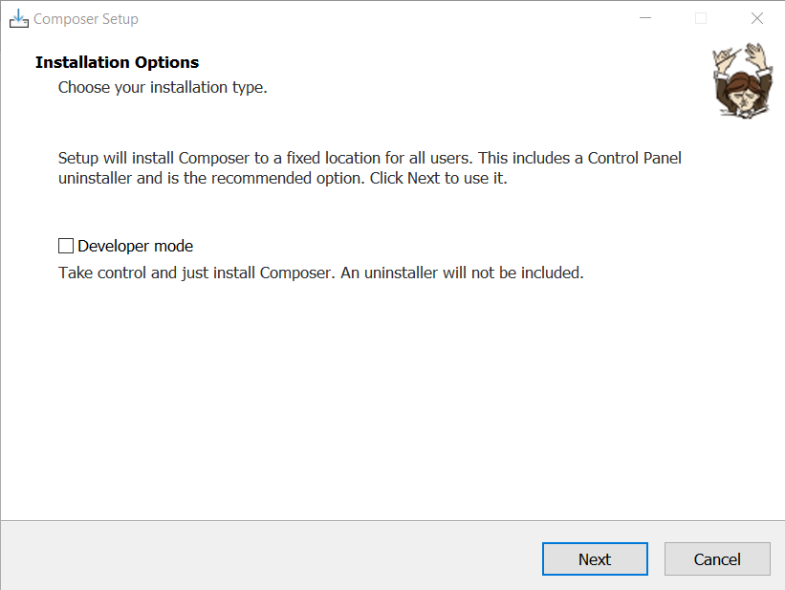 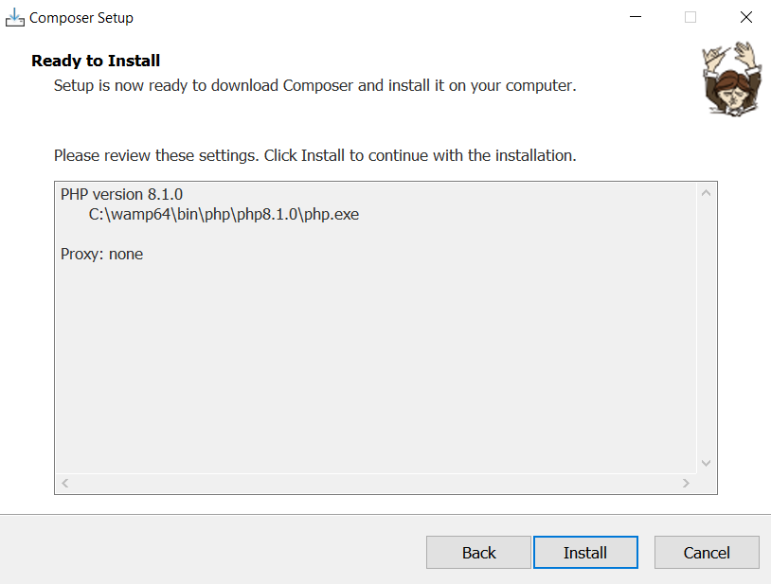

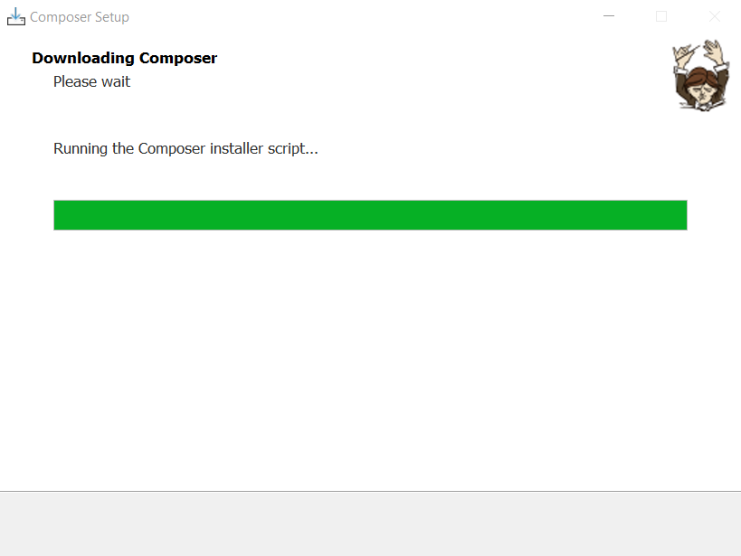 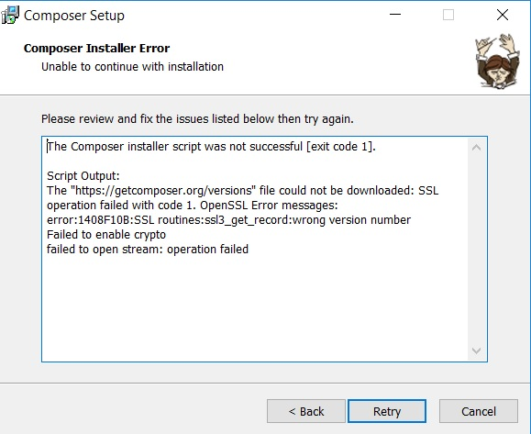

Note: If this error will occur, turn off your windows defender or firewall then retry.

**Example:**

Browse a package, or library at <https://packagist.org/>

E.g., <https://packagist.org/packages/phpoffice/phpspreadsheet>



**Installation of PHPSpreadsheet Library**

Use [composer](https://getcomposer.org/) to install PhpSpreadsheet into your project:

Command:

composer require phpoffice/phpspreadsheet

Output:

The composer create a file ***composer.json*** containing the list of libraries installed. Also, it creates a folder ***vendor*** containing all the library folders.

How to use libraries installed via composer?

To load all the libraries, include the file ***autoload.php*** from the ***vendor*** folder.

//Load Composer's autoloader

require 'vendor/autoload.php';

Then, all the libraries inside the ***vendor*** folder will be loaded automatically and you will be able to use it.

Example:

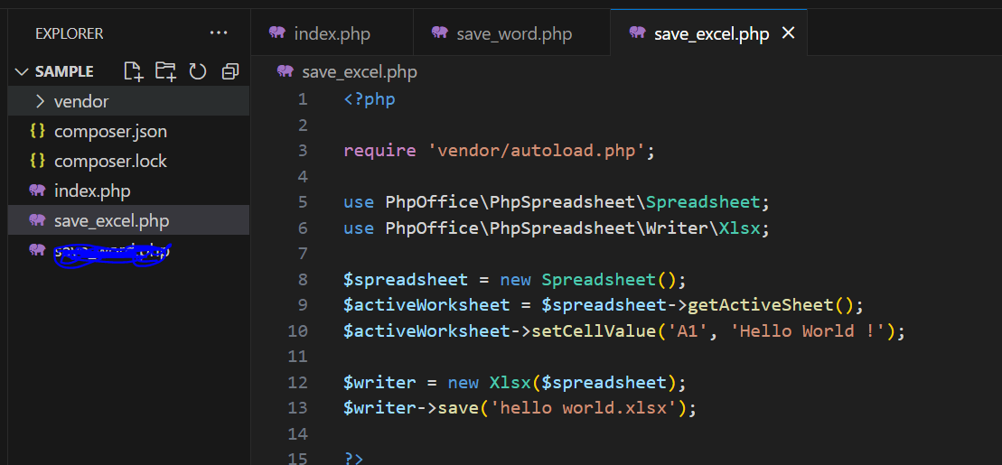

# Installation of Libraries into LavaLust Framework

From your terminal, go to the directory you want to store your libraries/vendor. This time, we will install it inside app folder.

Install the library via composer.

Example:

Now, the vendor folder will be created inside the app folder.

Before you can use it, we are going to load the autoload.php from out config.php settings.

With that, you can now use the libraries without requiring the vendor/autoload.php inside your controllers. It will automatically load from the configuration of your system.

**How to use the library?**

Example:

